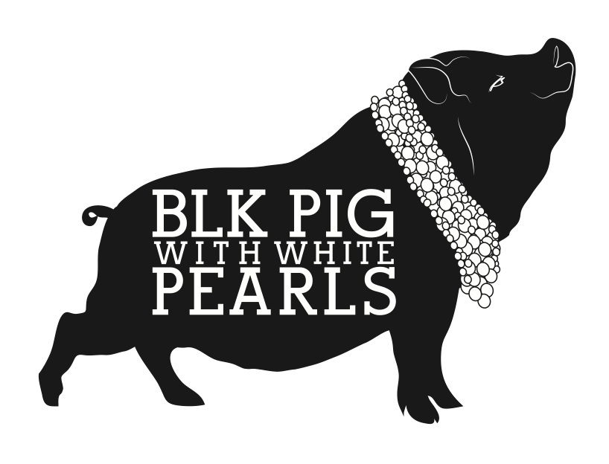
A la Carte Menu
All our dishes are sharing dishes & designed to share & we recommend a minimum of 2-3 dishes per person. Please note that all dishes come out of the kitchen as & when they are ready.
Please inform us if you or anyone in your group as any allergies or dietary requirements. Please note that any our nut dishes might contain traces of other nuts & are not recommended if you have any nut or peanut allergy.
Aperitivos
Olives £4
Almonds £4.50
Pan & alioli £4
Pan con tomato £4.50
Croquetas del dia £6.50
Cured jamon iberico £11
Mixed charcuterie lomo/ chorizo/ salchichon £12.50
Cecina cured beef £9
Jamon & manchego £11
Spanish cheeseboard £12
Manchego cheese £7

Fish & seafood
Fried calamari with a lemon mayo £10.50
Gambas Al Ajillo, prawns in a garlic & chilli olive oil sauce £13.50
Piquillo peppers stuffed with prawns with a creamy piquillo sauce £12
Boqurones marinate anchovies £8.50
Arroz negro black squid ink rice with calamari £11
Tempura bacalao, fried salt cod in a light crispy batter with salsa verde £13.50

Meat
Deep fried morcilla (spanish black pudding) balls coated in crushed almonds(not recommended if you have a nut allergy) with a piquillo peppers sauce £8.50
Chorizo in a red wine sauce £9.50
Croquetas del dia £8
Iberico pork ribs with a seville orange marmalade glaze £12.50
Grilled iberico pork skewers with a salsa verde & almond puree £11.50
Empanadillas del dia £8.50
Solomillo Iberico, grilled 100% acorn fed black pork with patatas panaderas £18

Veg & Vegan
(please see our separate vegan menu for more options)
Padron peppers with Maldon sea salt £7.50
Escalivada roasted red peppers & aubergine on sourdough toast with ailoi £8.50
Tortilla de patatas with aioli £7.50
Beetroot carpaccio, blue cheese & walnut salad & honey olive oil dressing £8.50
Grilled marinated artichoke with a garlic & parsley dressing & manchego cheese £10.50
Vegan lentil meatballs in a tomato sauce £8.50

Sides
Patatas bravas with a spicy tomato sauce & aioli £6.50
Spinach with roast garlic £5.50
Green salad £3.50

Desserts
Churros with a hot chocolate sauce £5.50
Dulce de leche £5.50
Almond tart with lemon & honey cream £5.50

Please inform us if you or anyone in your group as any allergies or dietary requirements. Please note that any our nut dishes might contain traces of other nuts & are not recommended if you have any nut or peanut allergy.

